Dockerization is called containerization
Docker is NOT always the right solution
There are situations where virtualization (VMs) is necessary

1 is Dockerization called Containerization?
Yes.
When we say:
- Dockerization
- Container-based deployment
We mean:
Containerization
Docker is the most popular tool for containerization.

When Docker (Containerization) is Useful
Docker is best when:
- You want fast deployment
- You want same app running everywhere
- You want microservices
- You want lightweight setup
- You want easy scaling
Common use cases
- Spring Boot + MySQL projects
- Microservices
- Cloud-native applications
- Developer laptops & testing
Why Docker is preferred here
- No full OS inside container
- Very fast startup (seconds)
- Less memory usage
- Easy to share and reproduce
3 When Virtualization (VMs) is Necessary
Virtualization is required when:
- You need full OS isolation
- You want to run different operating systems
- You need strong security boundaries
- You are running legacy applications
- You need kernel-level access
[when we run different operating systems using virtualization,
each OS has its own kernel ]

Common use cases
- Running Windows + Linux together
- Old software that depends on OS
- Banking / Government systems
- Kernel testing
- Different OS versions on same machine

4 Simple Comparison
Docker (Containerization)
- Shares host OS kernel
- Lightweight
- Fast
- Uses fewer resources
- Not ideal for different OS kernels
Virtualization (VM)
- Has its own OS
- Heavy
- Slower startup
- Strong isolation
- Supports any OS combination

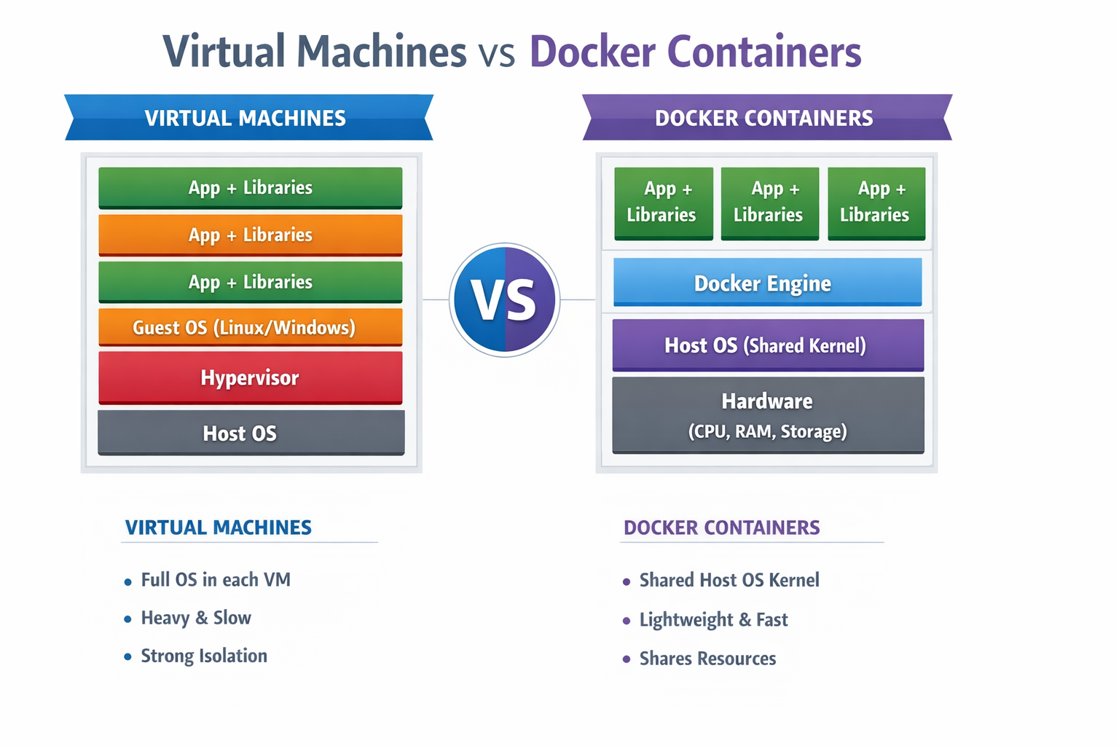

6 Can Docker replace Virtual Machines?
No
Docker and Virtual Machines solve different problems
In fact:
- Cloud providers use VMs
- Inside VMs, they run Docker
Both are used together.

“Docker is used for lightweight, fast, and portable application deployment.
Virtual machines are used when full OS isolation, security, or different operating systems are required.
Dockerization is also called containerization.”

“Docker is not a replacement for virtualization; it complements it.”

